Report on the Visit of 9th Standard Students and Faculty Members of Bharati Vidyapeeth Kanya Prashala, Pune to Bharati Vidyapeeth’s College of Engineering for Women, Pune under the SPPU School Connect 2.0 Program of New Education Policy (NEP)

Date: 30/01/2025
Participants: 9th Standard Students and Faculty Members.
Organized by: School Management and Bharati Vidyapeeth’s College of Engineering for Women, Pune
On 30/01/2025, a group of 9th standard students and faculty members from Bharati Vidyapeeth Kanya Prashala, Pune, visited Bharati Vidyapeeth’s College of Engineering for Women, Pune, as part of the SPPU School Connect 2.0 program under the New Education Policy (NEP). The initiative aims to expose school students to the world of higher education, specifically in the field of engineering, and to inspire them to consider STEM careers in the future.
Upon arrival, the students and faculty were warmly welcomed by the college's faculty and staff, who emphasized the importance of women in engineering and the college's commitment to encouraging female students to pursue careers in Science, Technology, Engineering, and Mathematics (STEM).
Campus Tour and Departmental Visits:
The students were then taken on an informative guided tour of the campus, where they had the opportunity to visit various departments, including Computer Science, Information Technology, and Electronics and Telecommunication Engineering. The visit provided the students with an understanding of the diverse range of courses and opportunities available at the college for aspiring engineers.
Following this, the group visited the First Year department, where they explored a variety of well-equipped laboratories. These included Engineering Physics, Engineering Chemistry, Engineering Mechanics, Electrical Engineering, as well as the Drawing Hall, Tutorial Room, and classrooms. The students were particularly fascinated by the state-of-the-art laboratories, which offered hands-on learning opportunities that complemented their theoretical knowledge. The practical learning environment gave them valuable insights into the practical applications of engineering concepts, making the visit both educational and inspiring.
Interactive Session with Faculty:
A special interactive session was organized for the students, where they were encouraged to ask questions regarding the various engineering courses offered by the college. The faculty explained the details of the curriculum, future career prospects, and the essential skills needed to excel in the field of engineering. The session was insightful and allowed the students to gain a deeper understanding of the engineering world, clearing any doubts they had about the course structure and the industry.
Conclusion:
The visit to Bharati Vidyapeeth’s College of Engineering for Women provided the 9th standard students with an enriching experience. They not only gained valuable knowledge about the field of engineering but were also inspired by the college’s commitment to empowering women in STEM fields. The exposure to modern laboratories and practical learning environments further fueled their interest in pursuing higher education and careers in engineering. This initiative under the NEP’s SPPU School Connect 2.0 program is an excellent step towards fostering a deeper connection between school education and higher education institutions, particularly in STEM fields.
The students and faculty members left the campus with a wealth of knowledge, inspiration, and an enhanced vision for their future educational and career pursuits in the world of engineering.
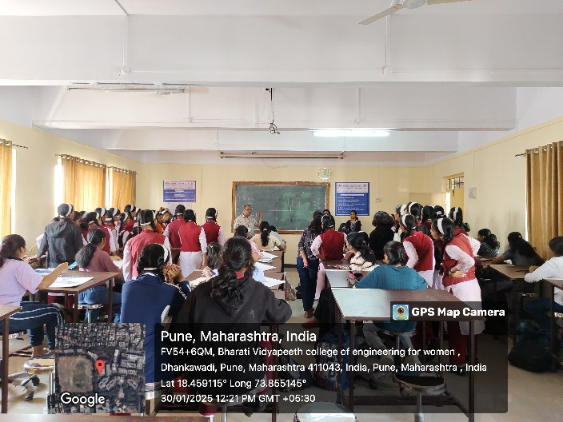 | 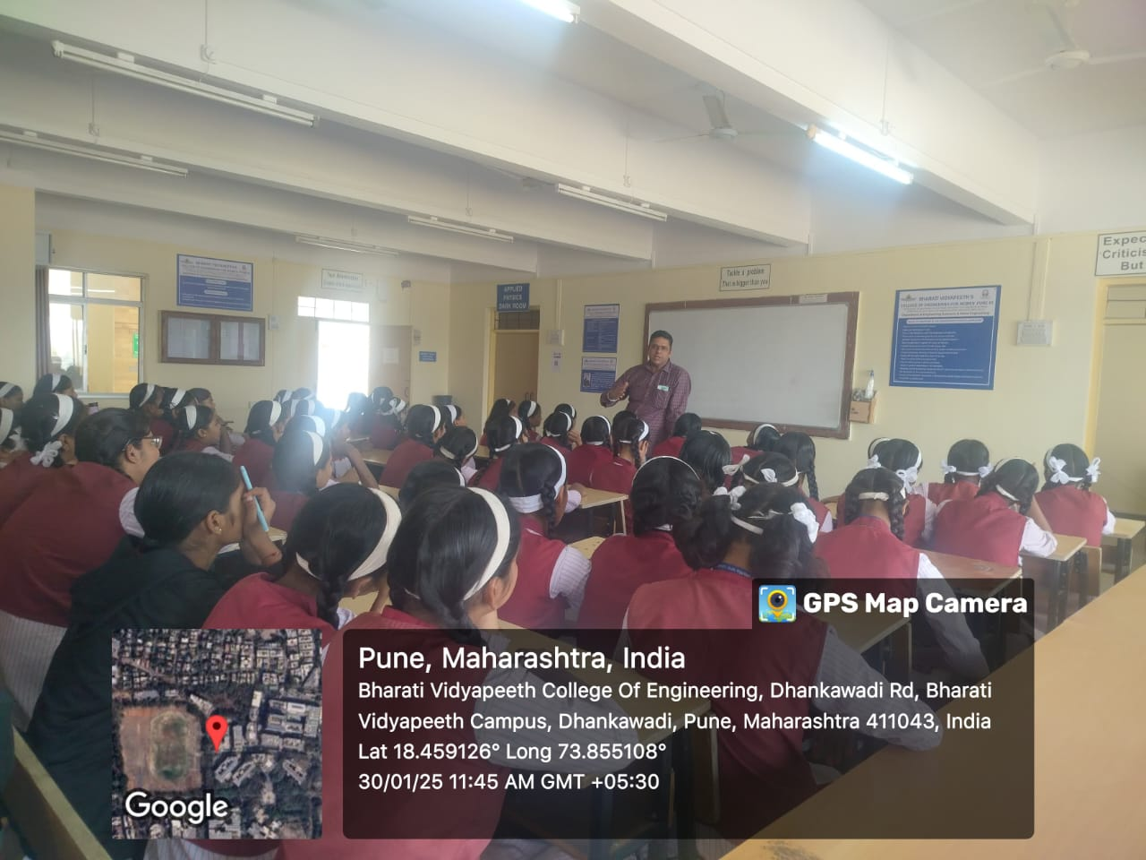
Prof. Y.D. Kute explaining the importance of Engineering Graphics | Prof. Dr. M. A. Patwardhan explaining the importance of Engineering Physics

